IBS Setup

## 

IBS

Sales Order Type

Set up Biz Partner

DI setup

Cost Model

Price List

Pricing method

Item Master

Create an item master entry

Configurator

Attribute setup

Parameters

Bill of Material

Bill of routing

Formulas

Package types

Configurator items

Simulator

Sales Orders

CSR

Production Check

Unable to enter orders

Performance

Product price incorrect

Formula name error

iSeries Setup

Misc

Folders

Events

# IBS

IBS is a collection of tables that when used can create a product based on user input for the BOM. Then have that product built using the BOR. Record who ordered the product and what price to charge based on the pricing information entered in the tables.

## Sales Order Type

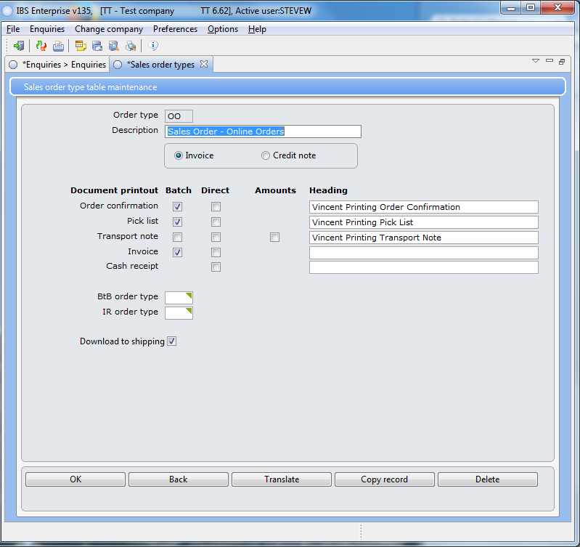

Should be set as above.

## Set up Biz Partner

Biz partners are the actual list of customers doing business with us. You can copy an existing partner change the Name, Internal name, and assign a biz number for them.

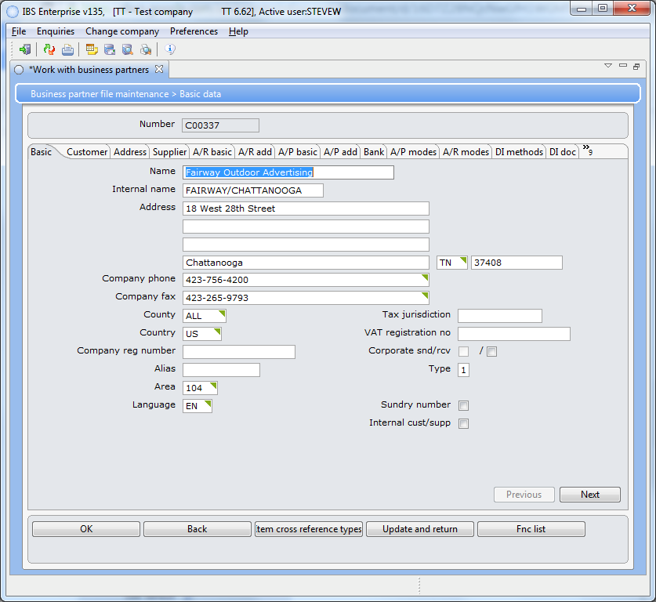

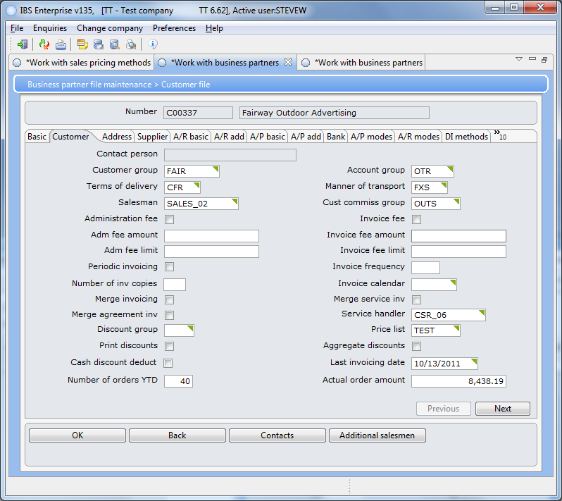 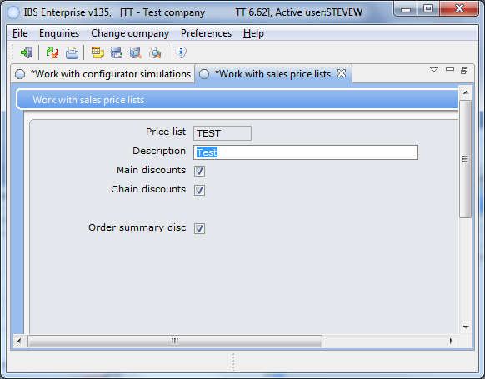

Set the Price List in this case to Test in TT. The price list tells you what options the customer will receive on the given items in it’s list. Each list should have the WEB items and as far as bulletins the price should 1.00 because we use product pricing which overrides the price list.

Note: The names used for items, lists, etc are for the test environment in production they have been giving a more meaningful name. Be very careful with the names once we had defined some formulas starting with numerics the system let us do this but when we used it in the BOR it errored out and it was very difficult to track down.

### DI setup

The DI methods tab needs INTEGRATOR set to active, just by pressing the OK button.

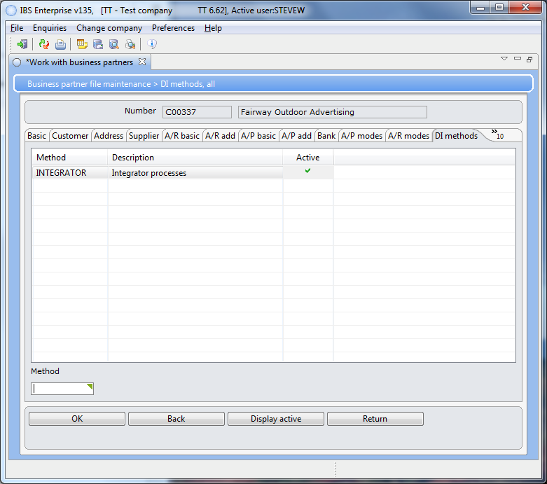and both DI documents need to be active.

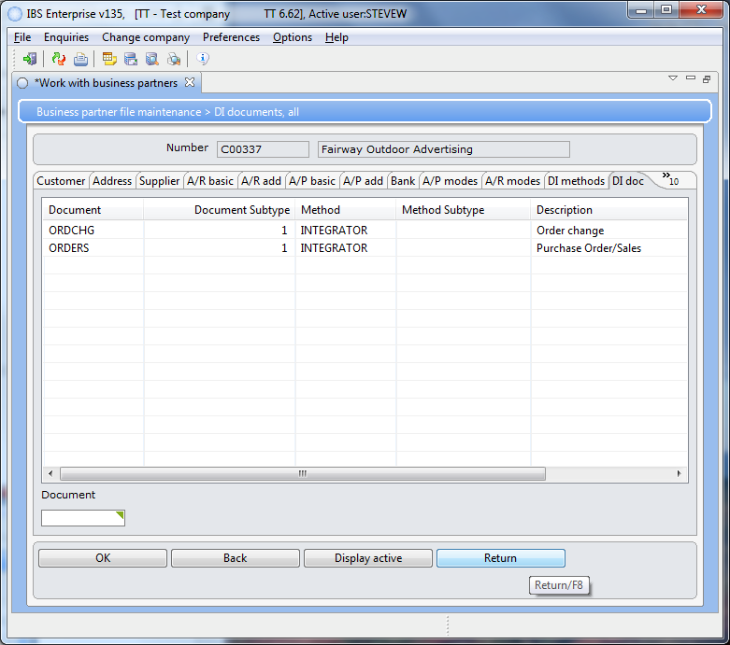

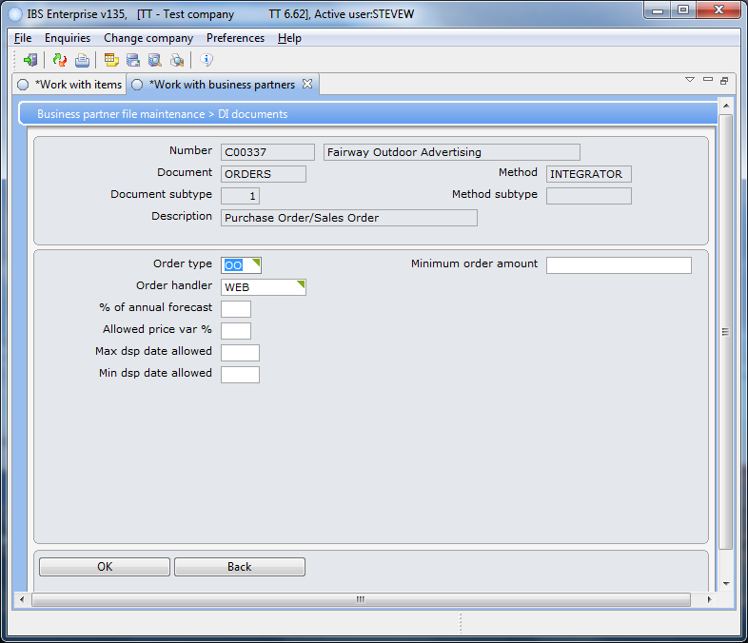Make sure that for ORDERS the order type is “OO” and the Order Handler is WEB or TJ REID.

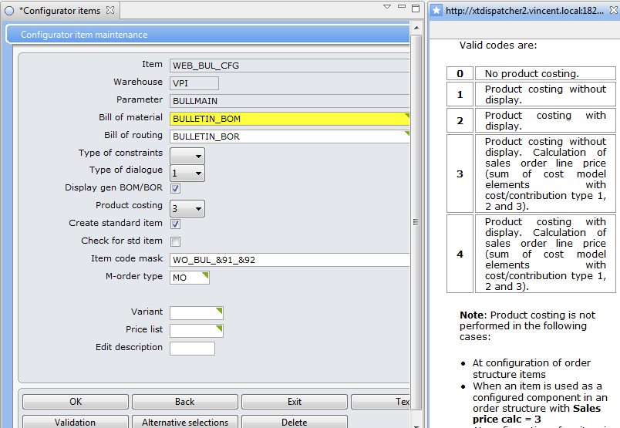You can test with a product costing of 4 but do not use it through the web it will cause the batch application to error.

### Cost Model

We use the cost model to establish customer pricing based on the material. The cost model is set up with elements that you define.

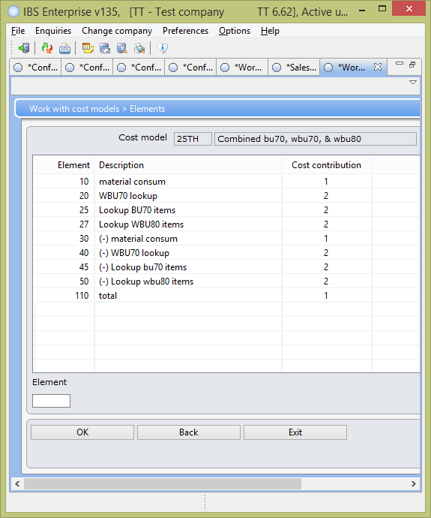You can have multiple elements. As you can see we had to add 20 and 40 to subtract what we had just looked up for WBU70. For some reason the system tries to add this twice. You can also chain the lookups so that you have a series of lookups for different settings, don’t forget the subtraction elements too. The total 110 will take 20 + 25+ 27 and use that for the cost, so if you add another element you **must add it** to this step as well. We had to do this BUL_CFG2/BU70.

Each element has a equation step and that is where we can add our customization.

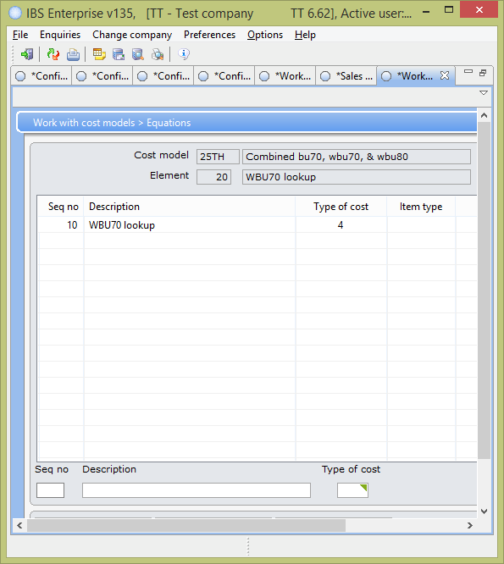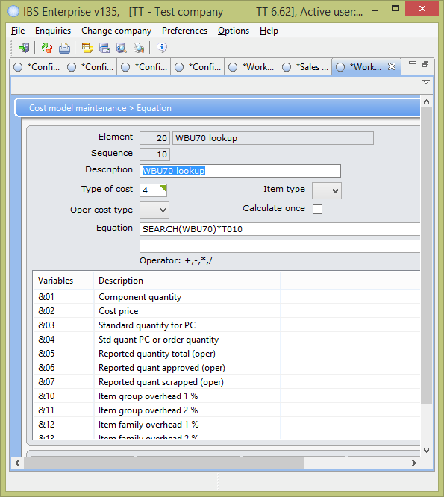 As you can see we added a lookup to a user defined table that contains the relationship material to customer price.

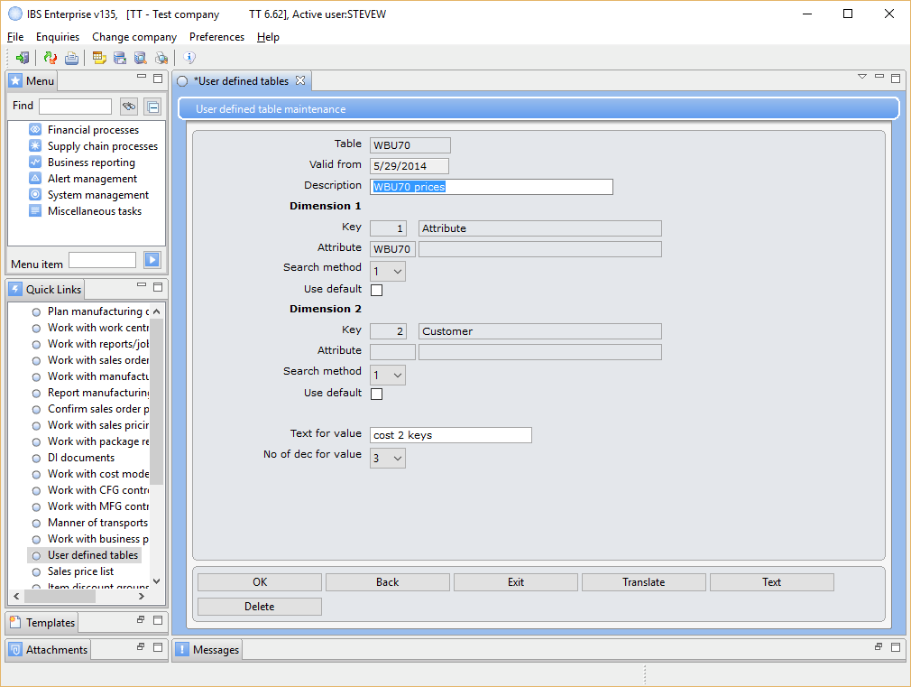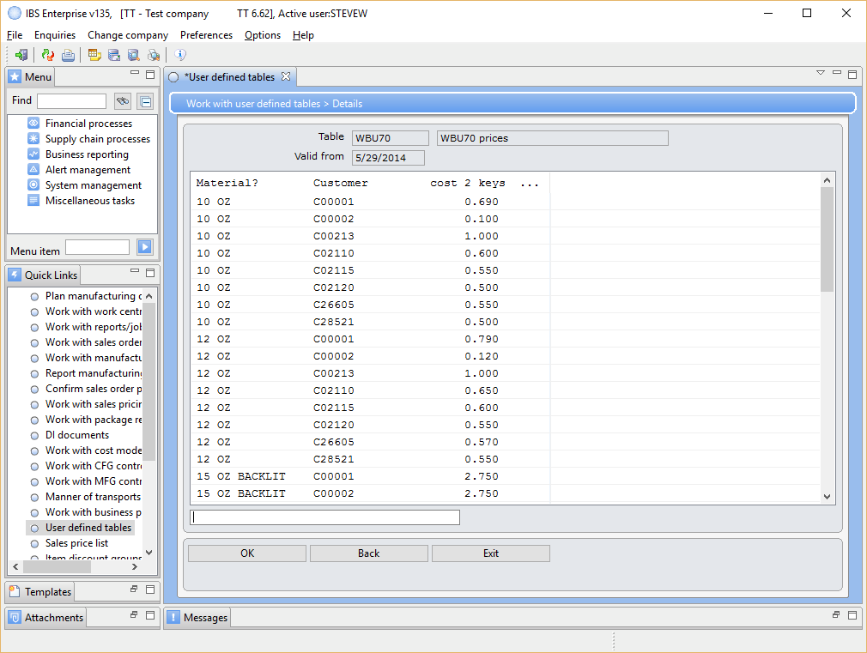

So we can assign a price on each material we offer to each customer who places an order for bulletins.

You then have to set the CFG and MFG control files with the new model. Note once a model has been used it can not be modified.

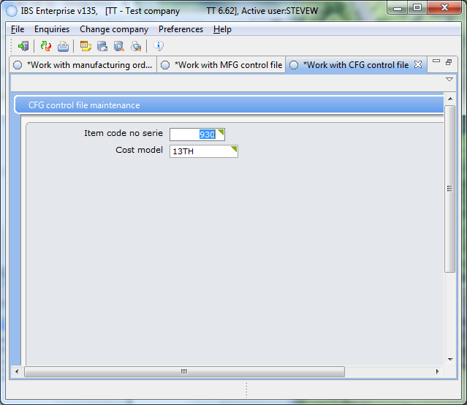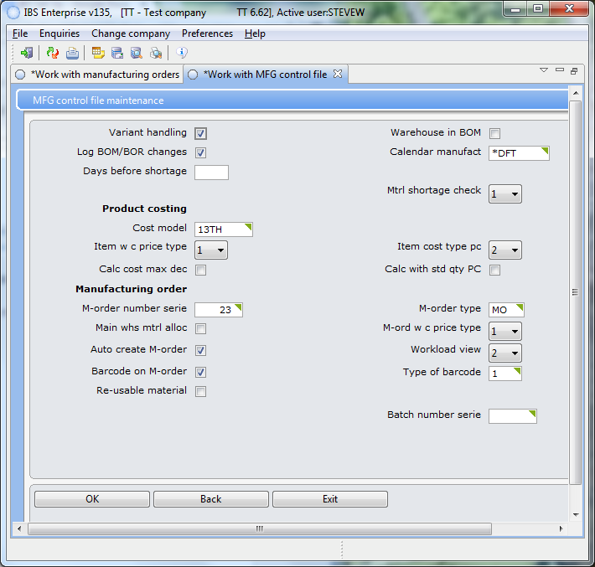

### 

### 

### Price List

Each partner is assigned a price list. The list will have the items available to that customer with some definition of how the price can be calculated. The following is a list of the price lists.

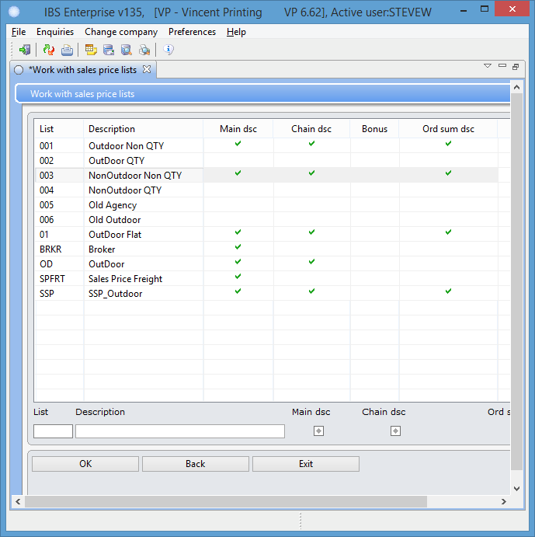

Price list 003 has WEB_BUL_CFG and WEB_SSP_CFG defined in it each with their price.

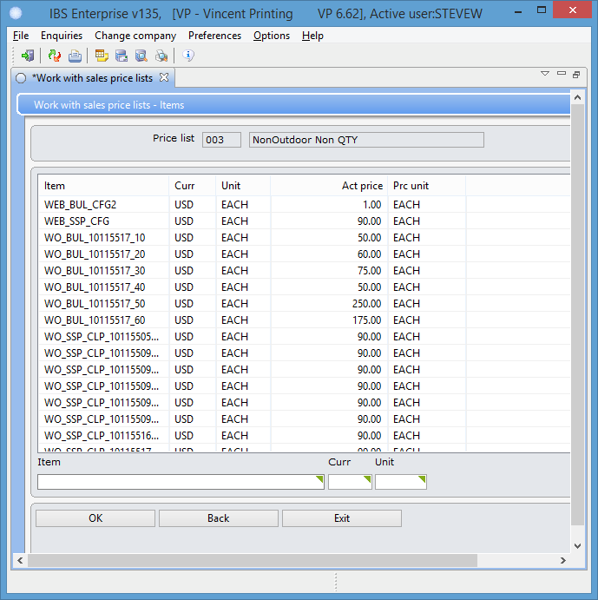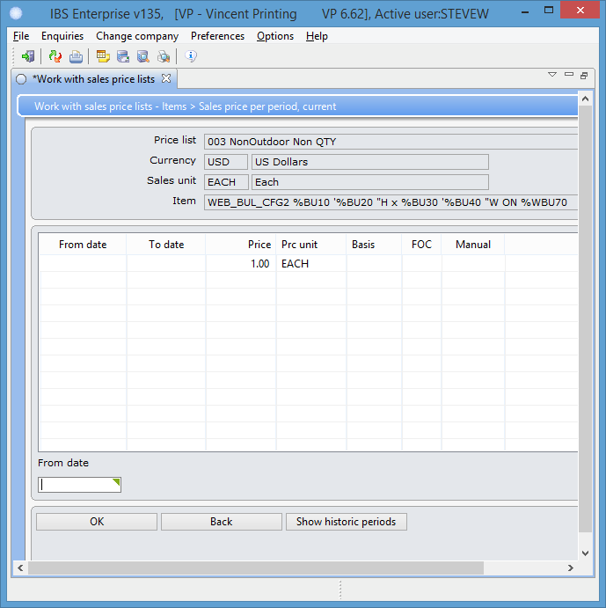

For SSP, POS, TRS, and FLS the price comes from the price list and the Pricing Method. You would set up the product in the give price list and then if the customer gets a discount it is set up in the pricing method.

### 

### 

### Pricing method

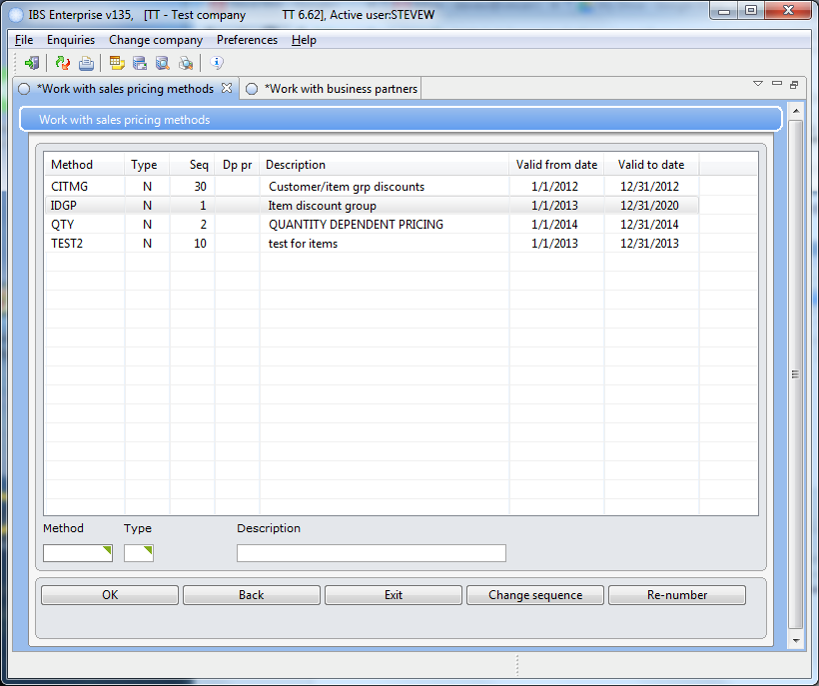We need to setup the pricing methods (a.k.a. discounts baby) for each product that we will offer. Right click and select the detail on the method that is used for the product.

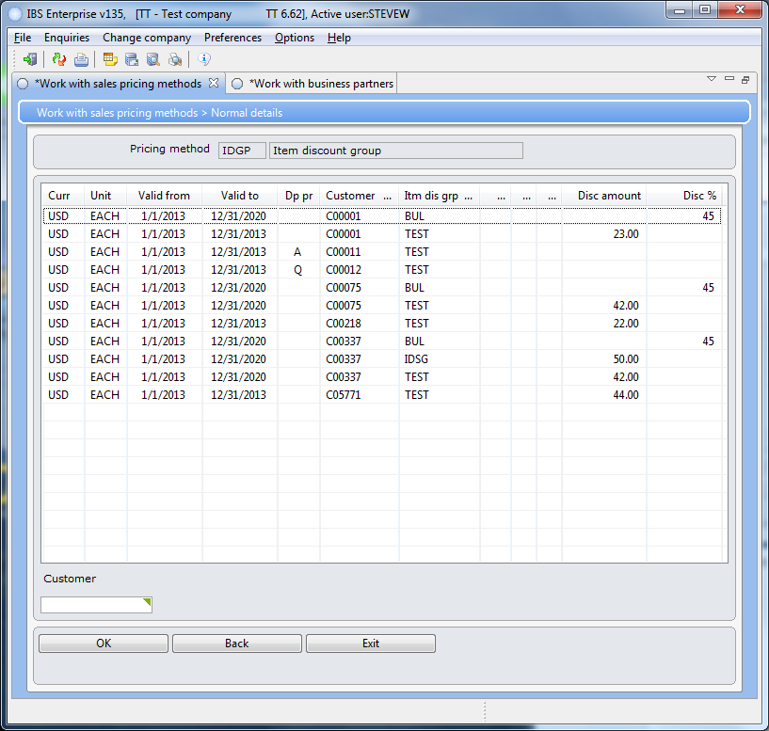Each customer will have an entry for each product they will receive a discount on. Currently we have two types of discounts.

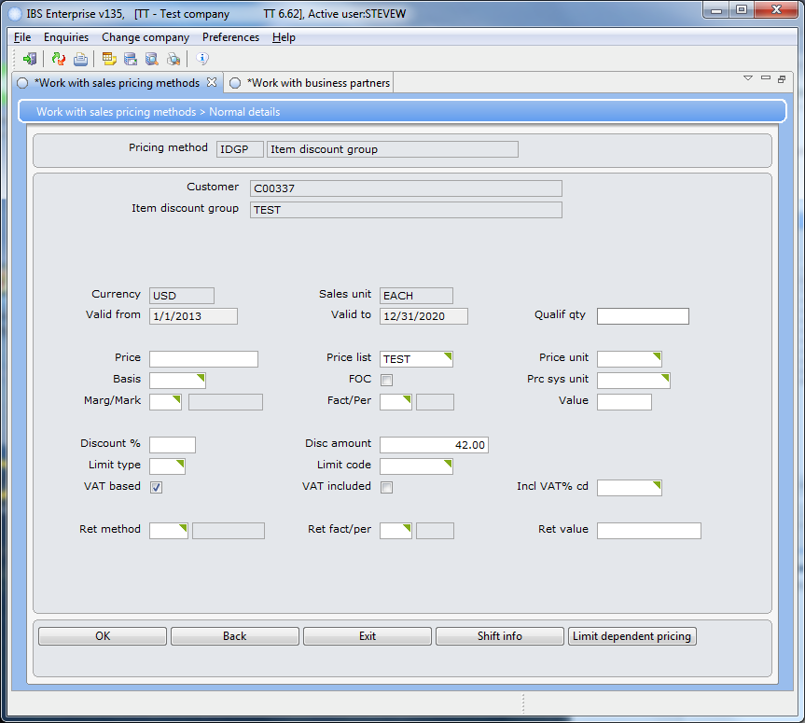Details of the discount.

The following is the list of the discount groups.

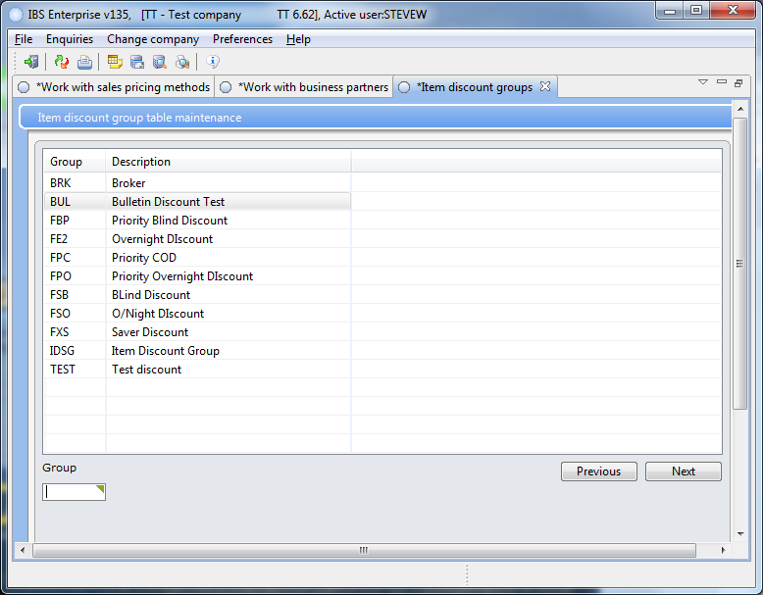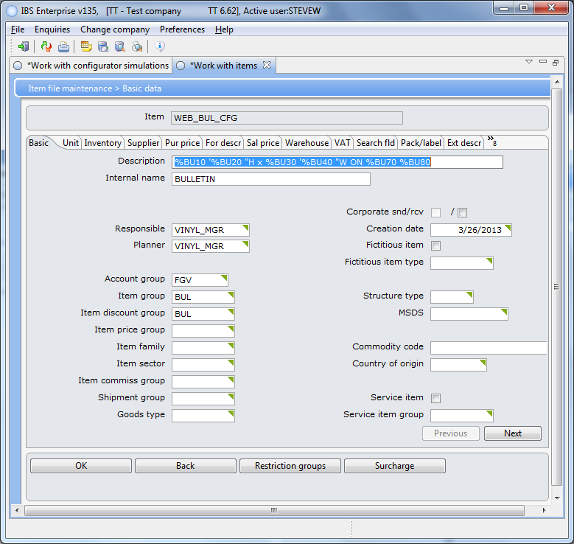

The discount group is selected for each product in the item master. The pricing method has the list of groups and the customers who receive the discount.

When you use the pricing methods the BOM becomes very important.

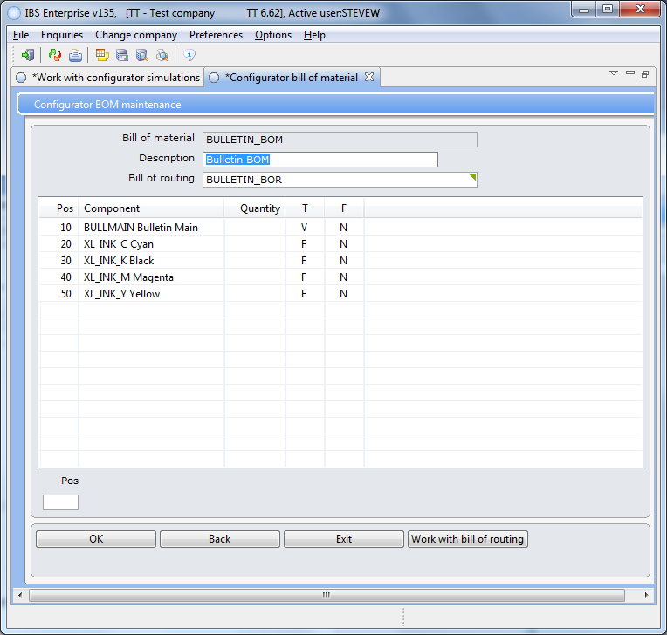

The settings here are used in the formula for calculating consumption. You need to turn off the ink entries and set them to non-mandatory, on bulletins.

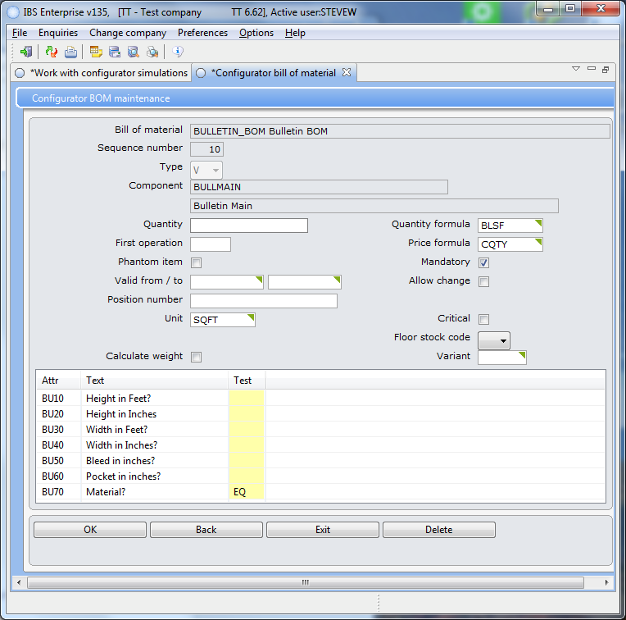We charge by the square foot so set the unit to SQFT and the formulas used for the product. When an attribute uses a selection list then set the test column to EQ and provide a configurator item with the match value for its selection from the list, see BU70 and the configurator item PE_196IN_4.2OZ_CLY in the attribute set up later in this document.

# Item Master

The item master hold all of the material and product information. It also will have an entry for the configurated items for the configurator to build with user input. You can think of them as templates.

## Create an item master entry

You can copy an existing item to help with entry.

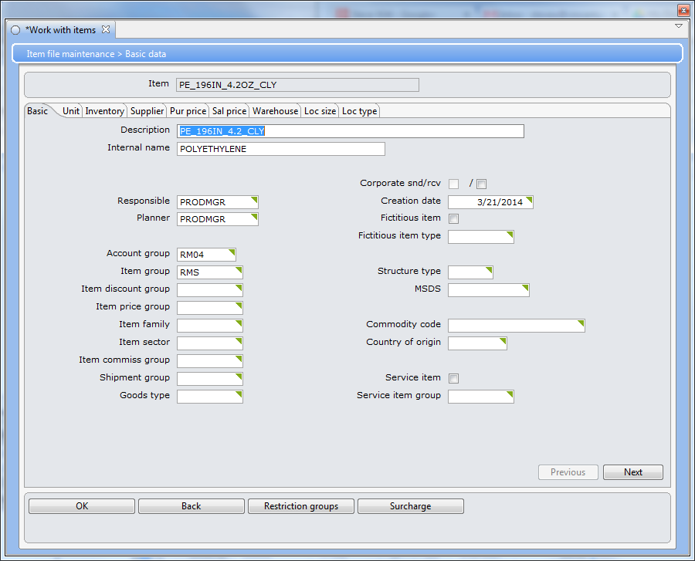You can compare the item to a like item.

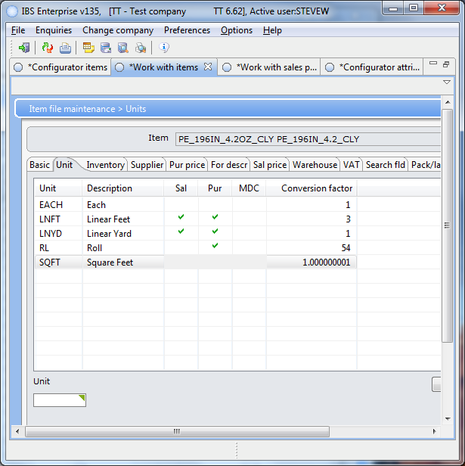

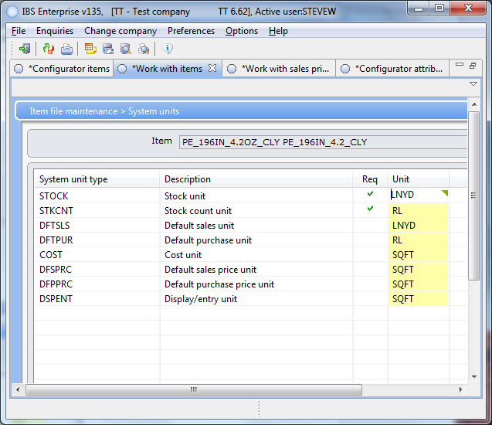

Make sure that the COST, DFSPRC, DFPPRC, and DSPENT as above.

Once you get to the Warehouse tab

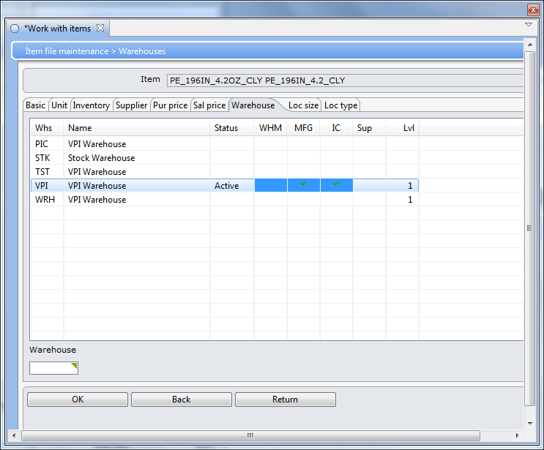

Double click on the VPI and hit enter until you get the screen below. Enter the new item’s price and cost.

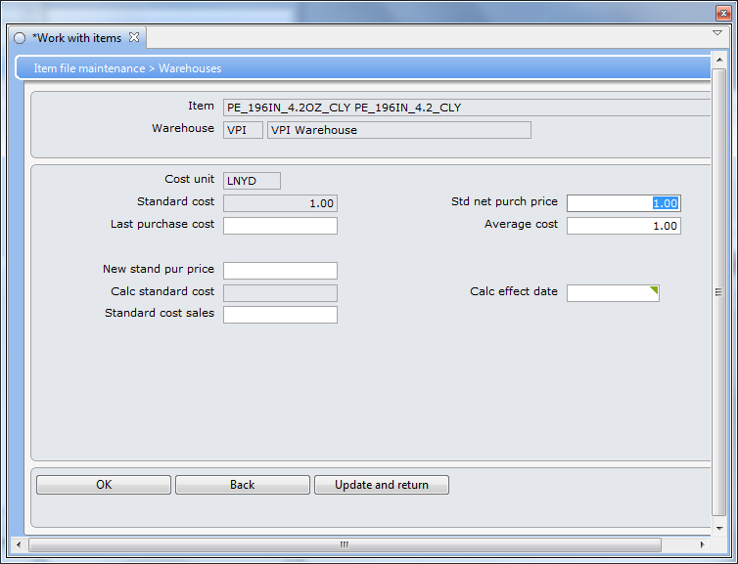

NOTE: Anytime you change the pricing on something and want to run the simulator don’t forget to “Refresh Landed Cost” menu item.

The item master will have an entry for the configurated item that is used to by the configurator to tie everything together.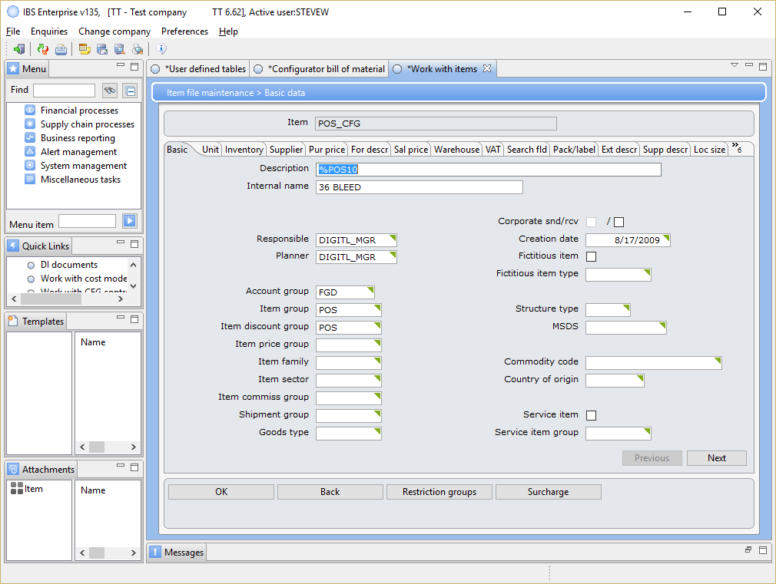

## 

# Configurator

The configurator uses the attributes, parameters, BOR, BOM, and the item to build a product based on parameters entered by the user.

## Attribute setup

Once you have the item master setup then you can add it to a configurator item. You have to use the green screen application in order to maintain the configurator attributes. Below PE had to be added to attribute BU70 using the green screen method.

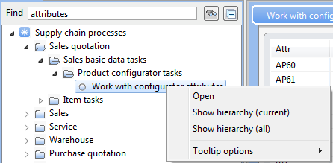You can right click on the menu item to view the hierarchy. You use this path to aid you in your navigation on the green screen application.

After you have completed the green screen setup the configurator PE_196 item must be created so that the relationship between the selected attribute item BU70’s value PE to the item master PE_196IN_4.2OZ_CLY.

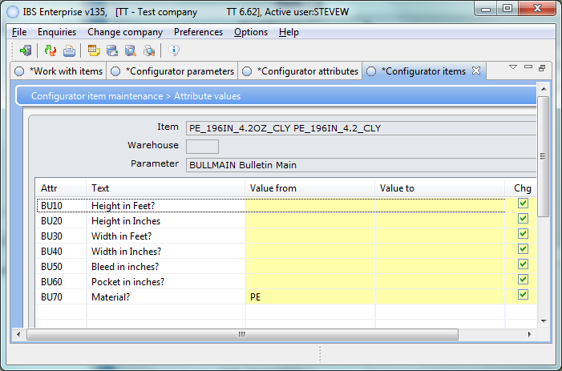

## Parameters

Parameters are nothing more than a collection of attributes. WO_BULLMAIN parameter has seven attributes.

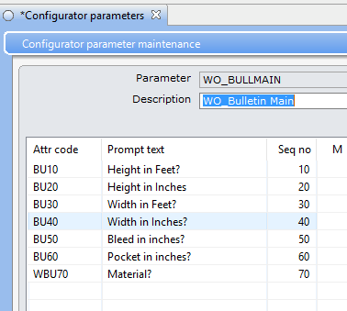

## 

## 

## Bill of Material

The bill of material holds the items that will be used to create the product in the manufacture process.

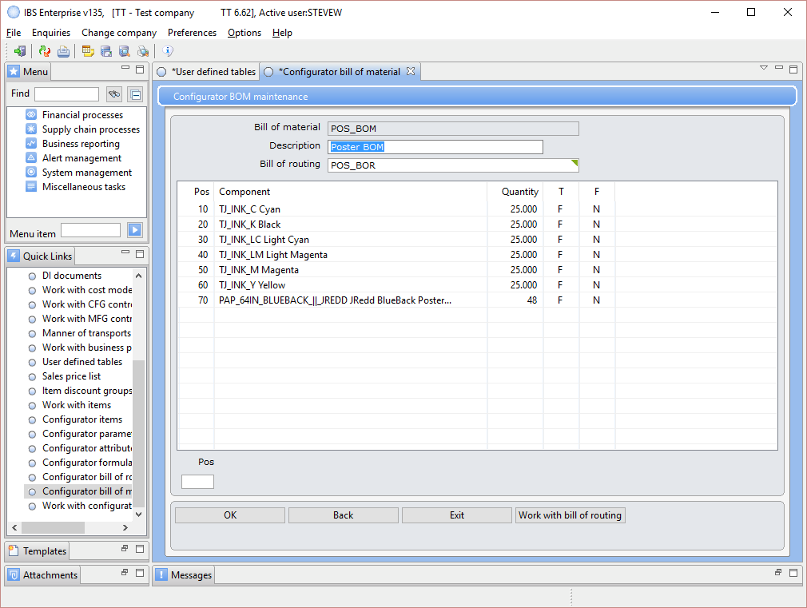

## Bill of routing

The bill of routing is a collection of the work centres (a.k.a. departments) that will perform the work to create the product.

## 

This bill of routing has five steps that require someone to indicate the step was completed. There is also text added to the last two steps that has additional instructions for that department. There can be customized instructions using a combination of parameters and formulas.

## 

## Formulas

Formulas are used to provide additional information for the building of the product. For example there are a series of formulas that calculate the square foot of used material for each product.

The web needs to charge for shipping so we have set up formulas that pass the variables needed for the fedex service. The formulas that we care about now are VOLBL and WGTBL for bulletins.

VPI online uses VOLBL and WGTBL to pass data to the FEDEX web service.

VOLBL has the following formula.

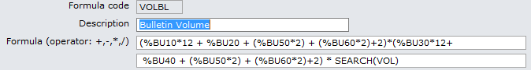

Which has a user defined table lookup in it--VOL--so we need to check it out.

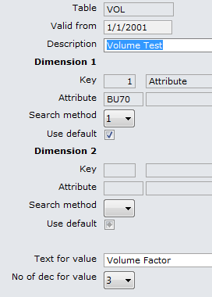 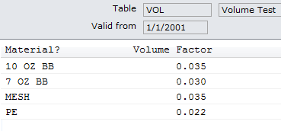VOL is a table of attribute BU70 which is the material the user can select from. The following is the list of material. PE was added.

The weight formula looks like this.

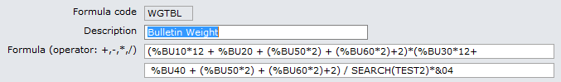

And uses the user defined table TEST2. BTW--Weight Factor is Dimension 2.

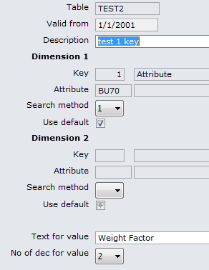 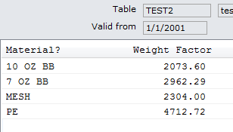

Any product would need to be added to the tables.

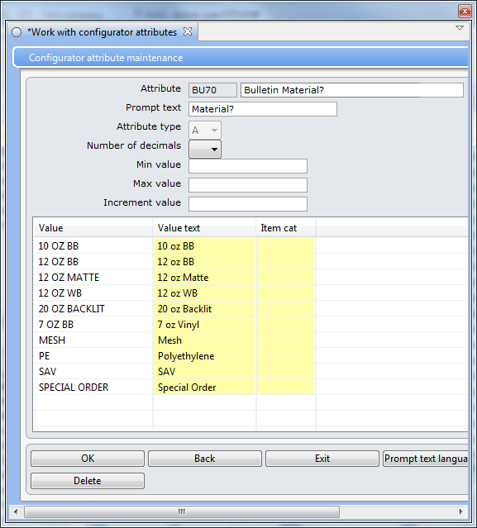So PE_196IN_4.2_CLY is an attribute of the configuration attribute BU70. BU70 is an attribute of the parameter BULLMAIN which BULLETIN_BOM uses. If the user picks an item that does not have the relationship setup, such as 12 OZ BB, the web will error.

### Package types

Shipping Box sizes are set up in Package types. Based on the weight of the material then you would have it’s box size. This is used in the web process to get fedex rate charges.

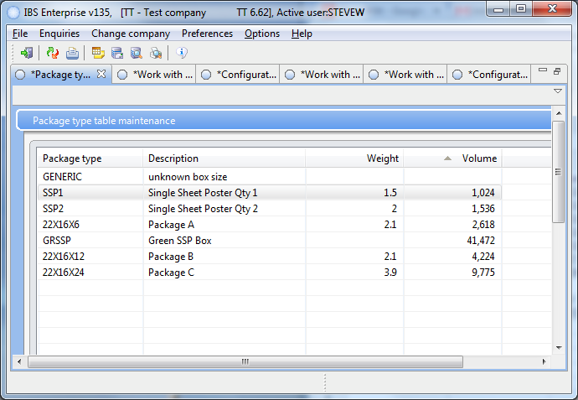

Working with Sales Orders is where you can review sale orders plus the following:

* To add an additional line to an order copy the current line. Change the item from _10 to _20 for example and then enter a quantity.
* You also use the WEB_ items to create a new line item.

Manufacturing order maintenance is where you can review mfg orders plus the following:

* Manually change the statuses on the steps to make it appear as though the step is complete.

## Configurator items

It is the configurated item that ties everything together. The item brings in the parameter that has the attributes for the build and the BOM that has the list of material and the BOR with the work centres (a.k.a. departments). The configurator takes this information and the attribute that the user has entered and creates the sales order.

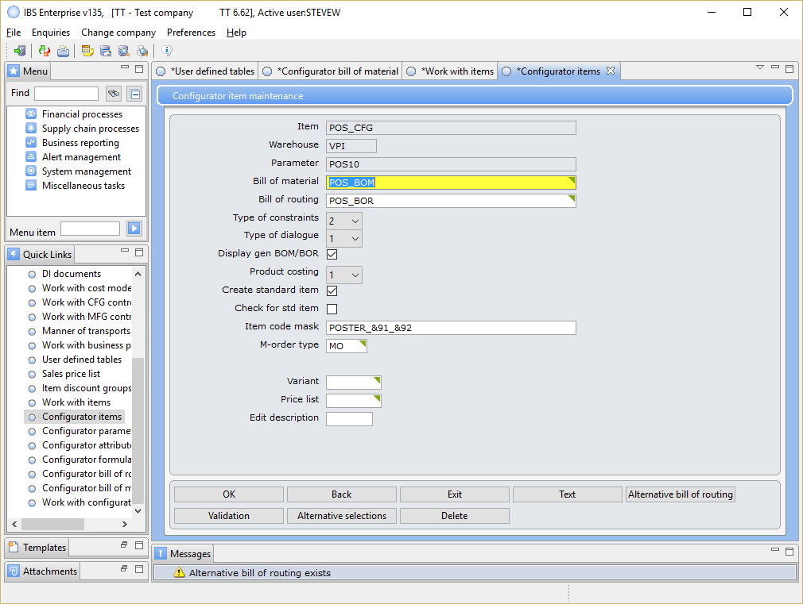

Notice the message. The configutrated item can have several BORs and you can specify their order and additional creatia.

Press the Alt bill of routing button.

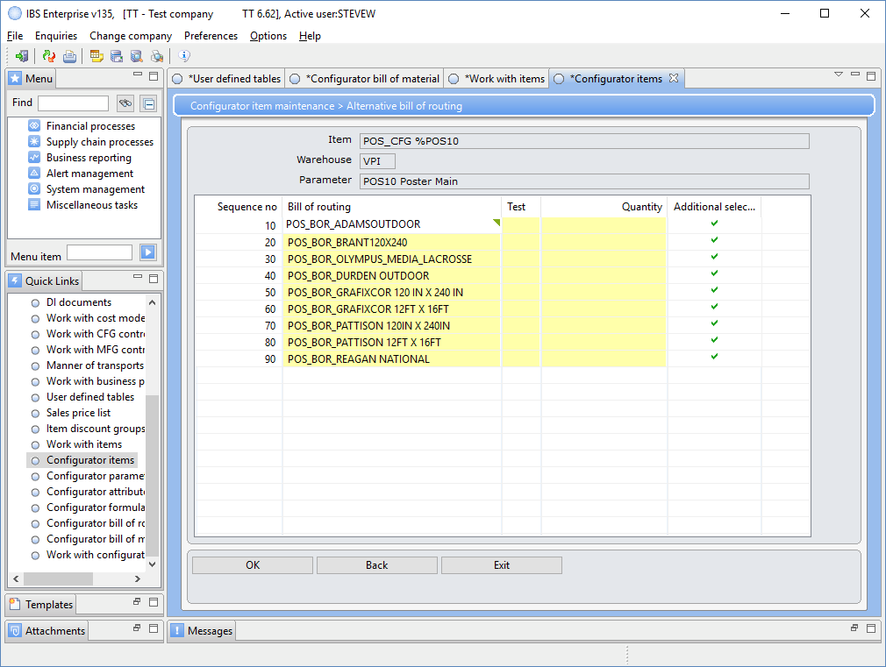You enter the order the different material and specify when each is selected. If there is no match then the BOR on the main page is used in this case POS_BOR. The following BOR would be used if the user selects REAGAN from the list in the POS10 attribute.

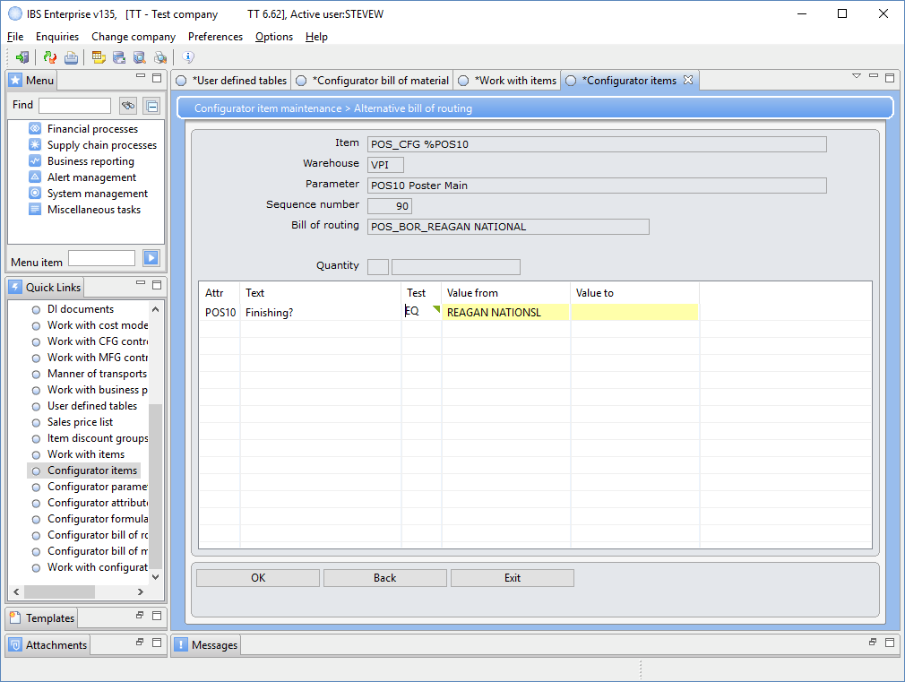

# Simulator

IBS client has a simulator that can be used to verify that the products are set up correctly.

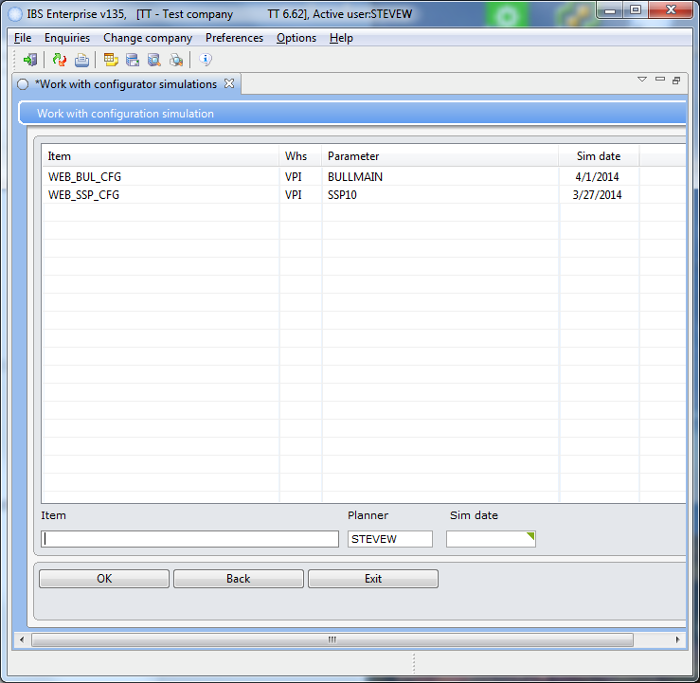 The simulator will have a list of simulations you run. You can select one from the list or add a new one from here or some context menus will allow you to start a simulation. F6 will start a new simulation too. Double click a list item.

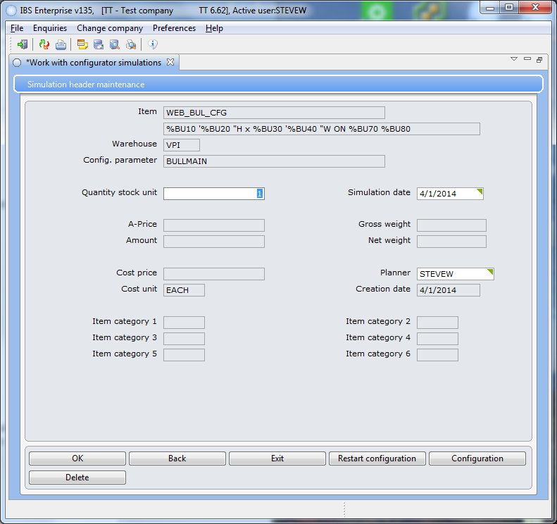Enter your quantity and the press the Configuration button.

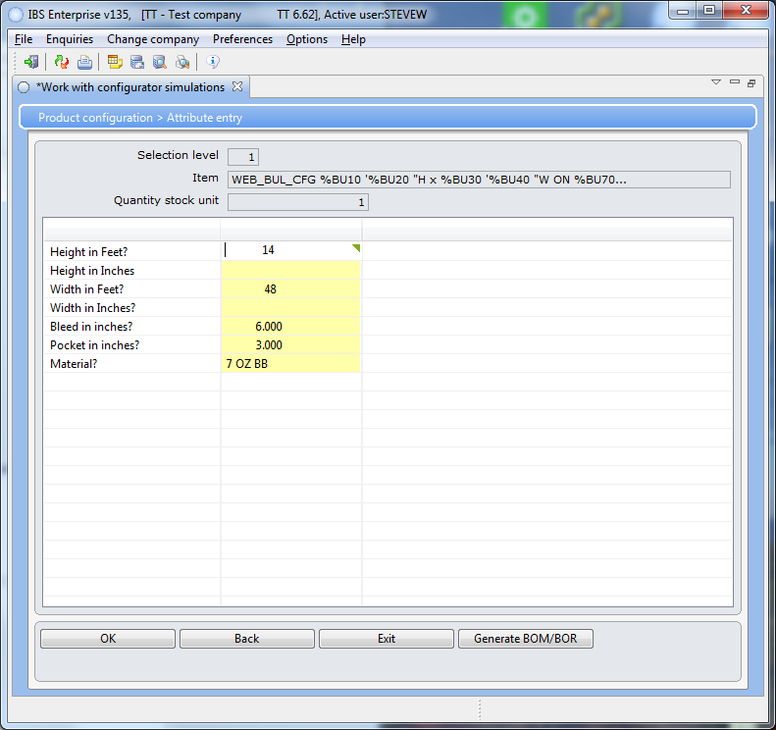Enter the products variable values then press the Generate button. You will see the results of the BOM first.

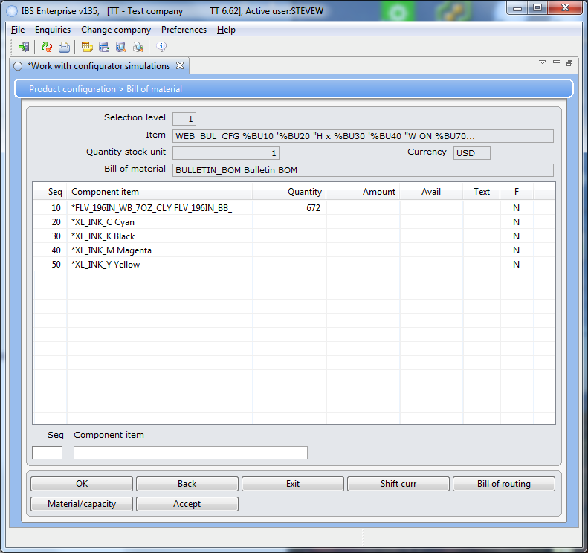Press the routing button to view the BOR information. When you press Accept you will see an actual order with the pricing information.

Going into the BOR you can view what was generated and view the text.

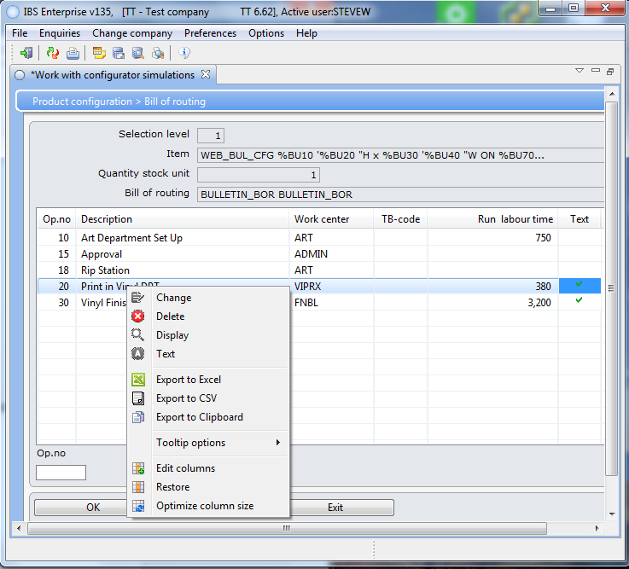From here you can select an item and select from the menu option. Text reveals results of the formulas and any supplied attributes you may have added to the text.

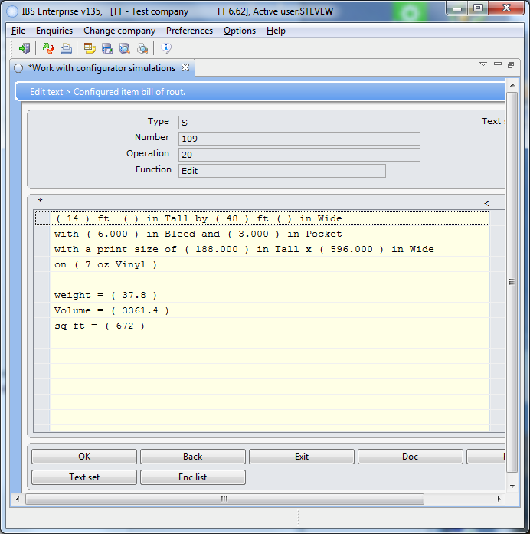You enter this text in the BOR entry. It is free form enter the attributes you wish to view.

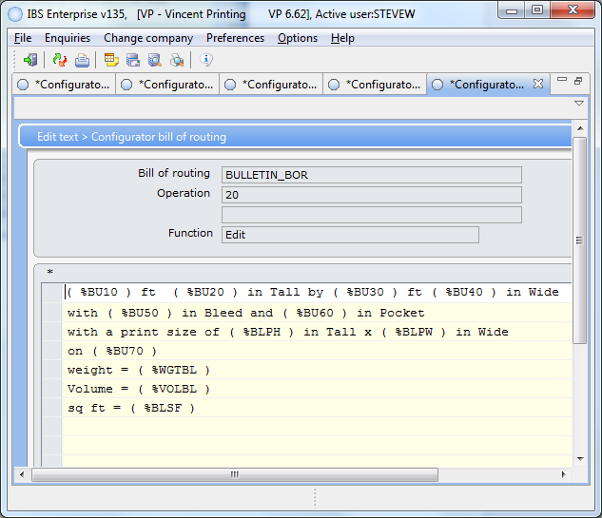

# Sales Orders

You can work with any of the sales order in the system. This is the CSR interface to place orders. But we can view any order and edit them.

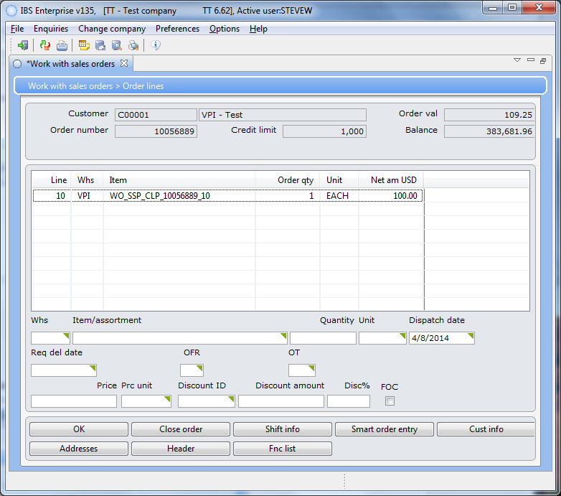We can add a line entry to this order by copying the item text and entering the qty.

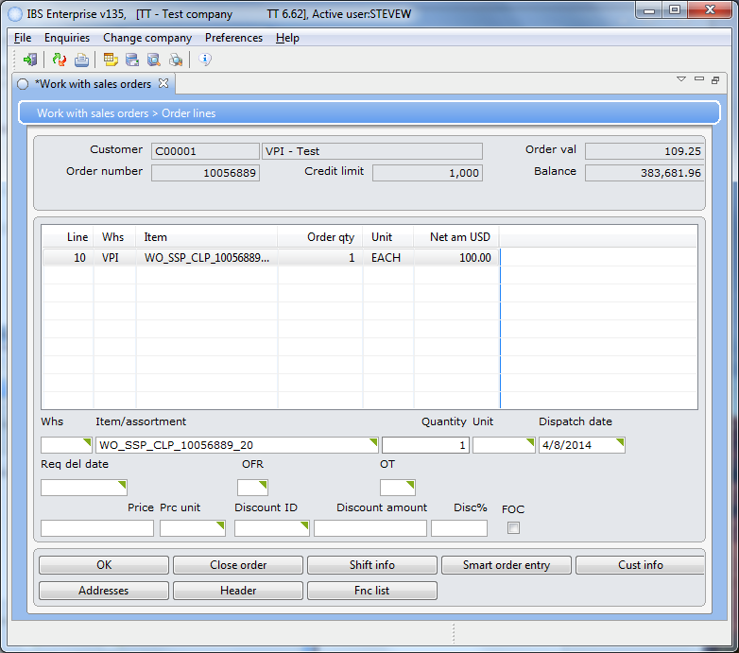

If the sales order is in a status of 10 you can right click it and then delete it. You can delete a sales order in a status of 20(a.k.a. that has MFG order created for it) by performing the following actions. Select the order you want to delete and then for every line item, right click and select BtB. I found I could select change as well.

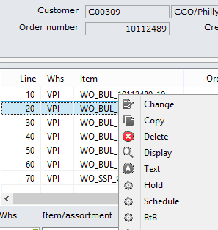 Change the quantity to some value. When you press the enter key you will receive a warning press enter again and then press f12. Once you have changed every line item in the order using this method you can delete the order. In some cases this will not work that is because there is another issue I am not aware how to correct it.

## 

## 

# CSR

CSR/AEs must be defined in IBS with a profile and an email address. This information is what appears on the sidebar in the CSR section. BTW-You have to create a signature entry as well it is the Handler entry on the profile.

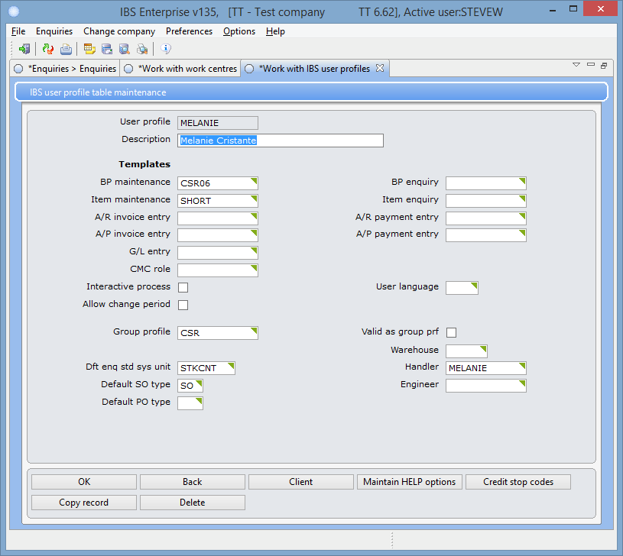

Enter the information about the user then press the client button to enter the email address. Right click the mail entry.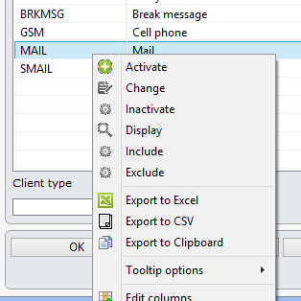

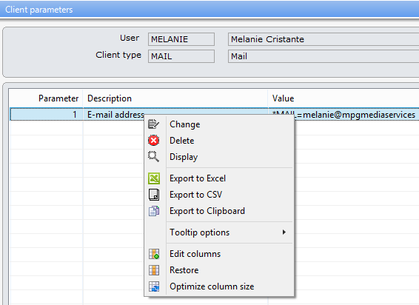

Right click the address entry and set it for the CSR user.

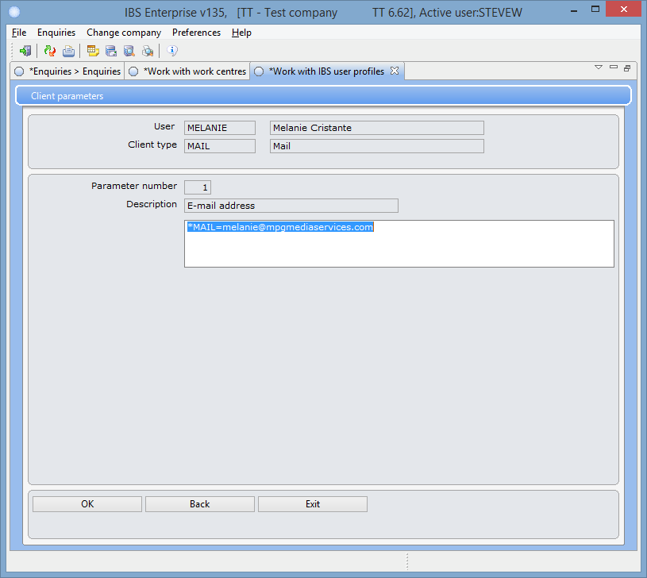

SELECT * FROM vt2662afvp.SROCLL WHERE ULUCTP = '*USERPROF' AND ULCLNT = 'MAIL' can be used to verify the entry is there.

# Production Check

This section outlines some of the actions you can take to review production issues.

For example:

* Check the integrator logs.
* Restart the integrator web service.
* Check the connection pools..

### Unable to enter orders

We had an issue that no one could enter orders the connect pools in the integrator had to be restarted.

Checking the Integrator connection pool logs would be helpful. There are two pools configured, one for TT and one for VP. Log entries there would reveal what's wrong with connections to Enterprise. Depending on the case, restarting them might be helpful.

### Performance

At times the speed of the systems slows. When we stop and start the connection pool for the environment it speeds up.

### Product price incorrect

We had an issue with new and existing product prices not calculating correctly. When we created a new web product and activated it on the web the pricing would break. Once the integrator service was restarted it priced correctly.

### Formula name error

We had developed several new formulas to calculate the material usage. When we tested we received an uncaught error. We could not find anything in the logs. I started from the beginning of the process to see if I might be able to track it down and test. The error would occur after the sales order was created and in the process of creating the manufacture order it would stop. I determined it had to be with the BOM/BOR. I found that the formulas had names that was causing the error. They started with numerics which on systems such as the iSeries numerics starting a variable name is not allowed. I changed one of the formulas to start with alpha and it worked.

# iSeries Setup

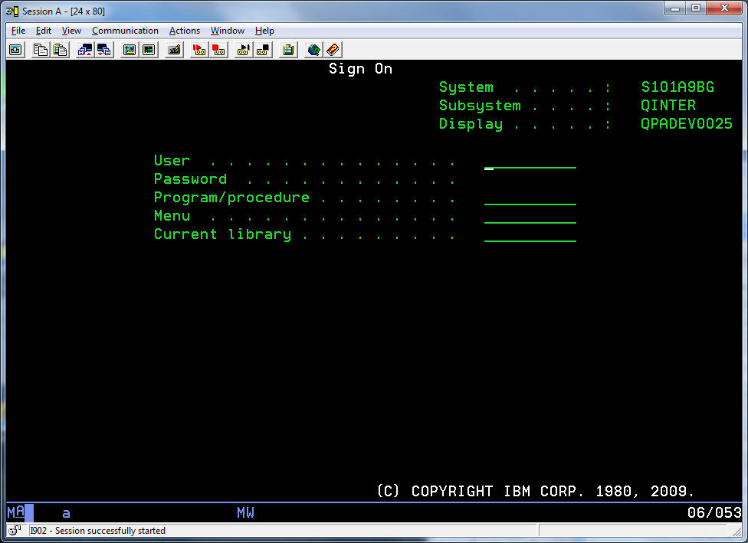 Sign in.

You will receive the following screen where you will enter s600.

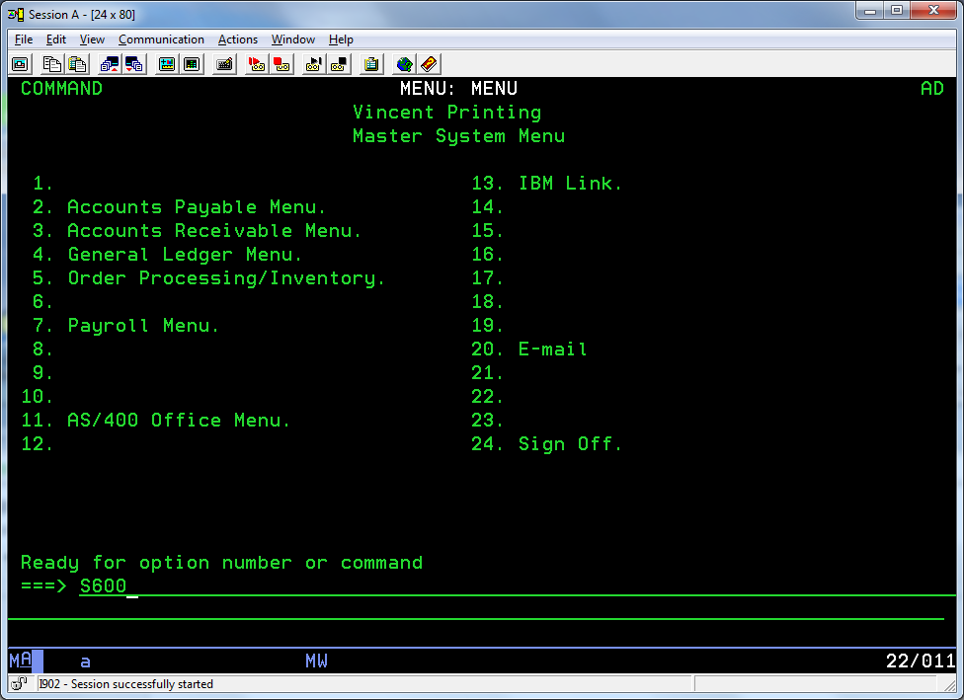

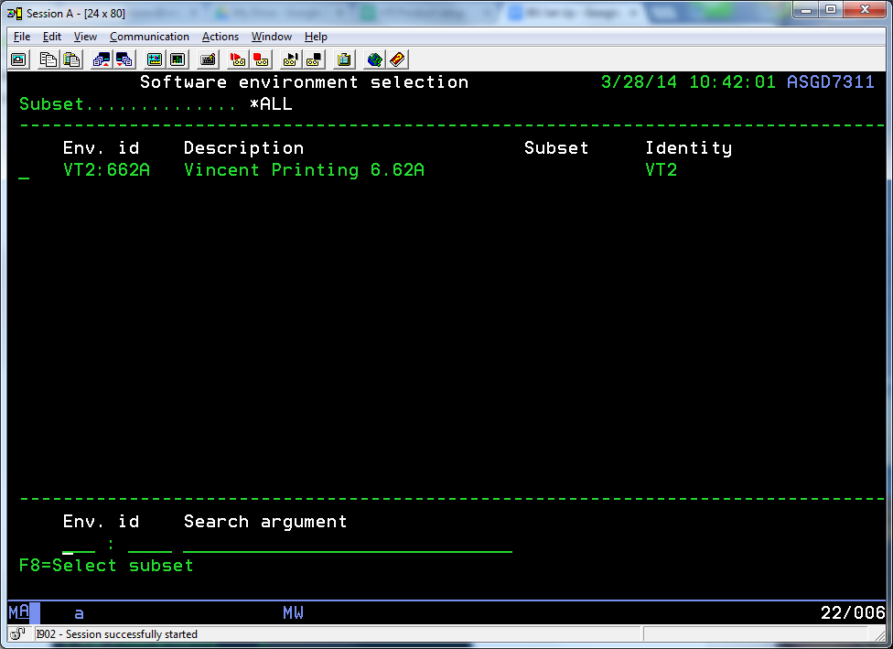Use the shift-tab and select the menu entry. Notice how the VT2662A matches the entry for the company TT/VP.

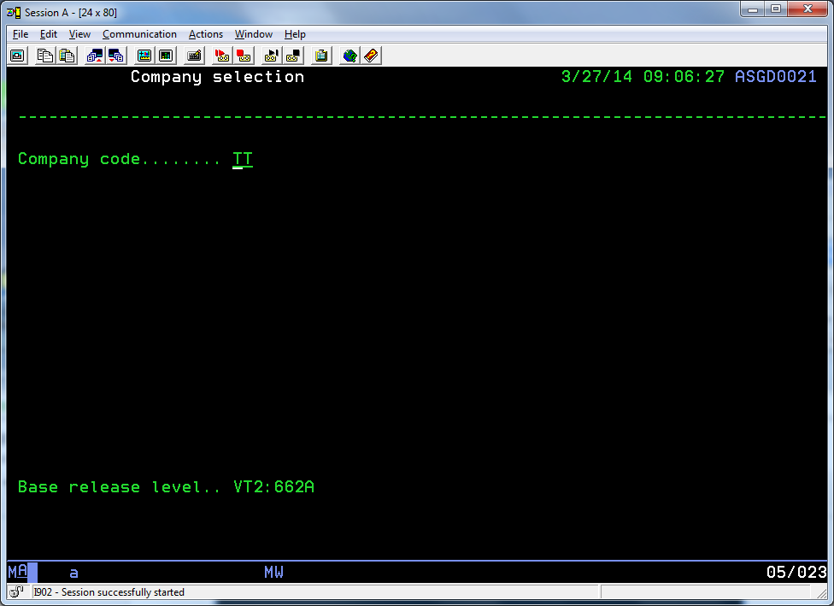Hit enter twice. The following screen appears. Notice that it has the same menu items as the IBS client has.

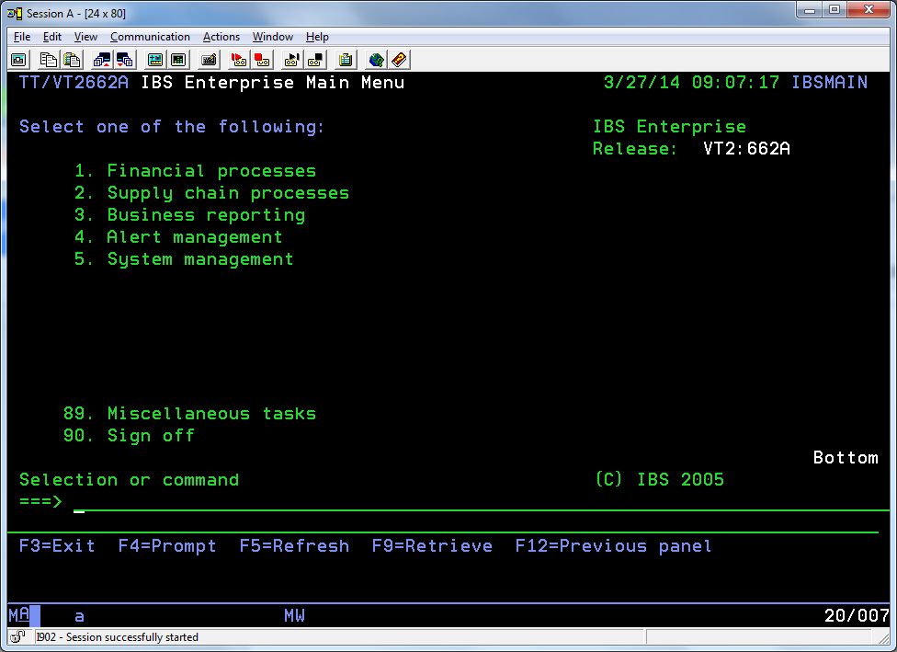 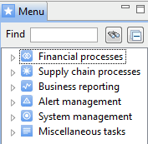

Here is where we can follow the path to the selection in the green screen



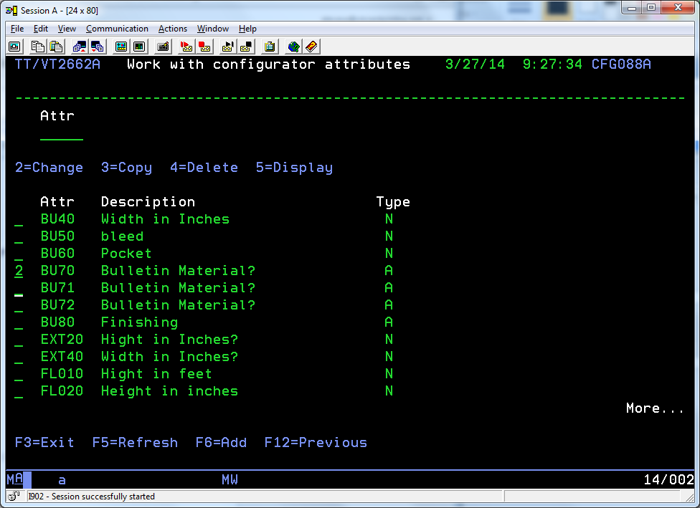 You can use shift-tab to position the cursor on a field to select it. Enter one of the options 2=Change; 3=Copy; 4=Delete; or 5=Display. You can use the Page Up and Page Down to view more information.

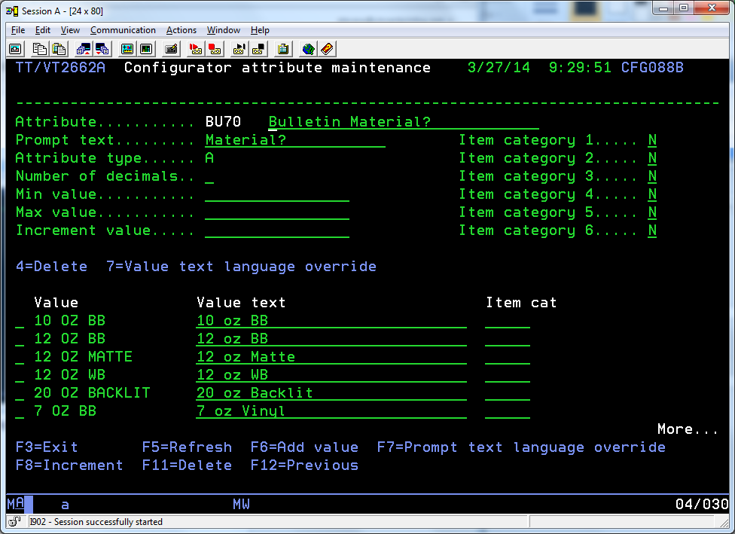

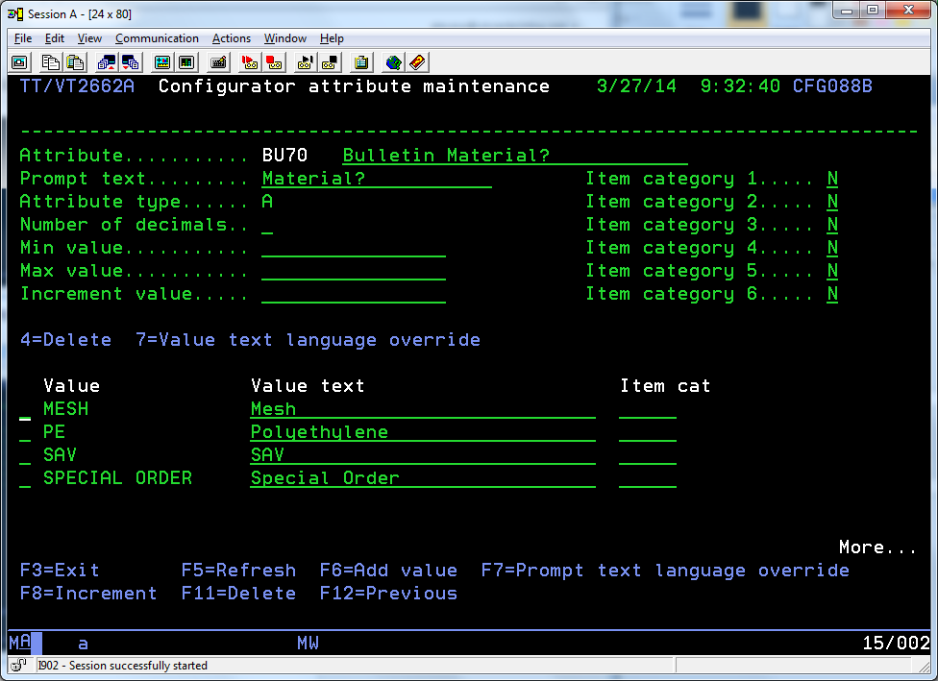 Here is where the entry PE has been added to the attribute BU70.

# Misc

In this section I will add a variety of information that I think is important but I don’t have a place for it as of this writing.

## Folders

The integrator has several folders that are part of the data flowing in and out of the system. Here are just some the folders.

\\192.168.0.56\software an area that I thought I would use to share software.

## Events

The following is a list of the event that are recorded in the system.

HN = Order Header Created

HI = Order Header Invoiced

NO = Order Line Created

OC = Order Confirmed *

TD = Order Delivered *

IN = Order Line Invoiced

PL = Order Line Pick List Confirmed

AR = Order Line Proof Ready *

AP = Order Line Proof Approved (proof approved notification is sent by the web interface, and won't show in the email log)

TS = Order Line Shipping *

TN = Order Line Transport Note Printed